Carrey infuses graduation speech with humor
By ANDY HALLMAN | May 27, 2014
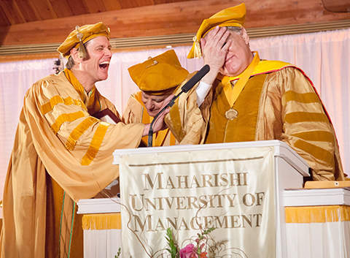
Courtesy of: MAHARISHI UNIVERSITY OF MANAGEMENT Maharishi University of Management president Bevan Morris, right, reacts in horror after Jim Carrey, left, tells him the university misspelled his name on his honorary degree. Carrey quickly assured Morris that he was only kidding. Carrey received an honorary degree of Doctor of Fine Arts Honoris Causa.
JIM CARREY
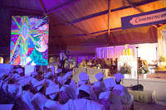
View More...
Ace Ventura. Lloyd Christmas. Fletcher Reede. The Riddler.
Graduates of Maharishi University of Management got to meet the man behind these and countless other characters when they walked across the stage in the Men’s Golden Dome Saturday where the commencement address was given by none other than A-list Hollywood celebrity Jim Carrey.
The star of films such as “Liar, Liar” and “The Truman Show” more than lived up to expectations, delivering an address that was equal parts funny and serious. Carrey even made a couple of good-natured jokes about Ayurvedic practices, which garnered uproarious laughter from the audience.
“Excuse me if I seem low-energy today,” Carrey began. “I slept with my head to the north last night,” referring to the practice of sleeping with one’s head facing south.
Carrey seamlessly weaved together sage advice and silly voices throughout his speech. He said he used to think that who he was ended at the edge of his skin, and that he had been given this “vehicle called a ‘body’ with which to experience creation.”
“I couldn’t ask for a sportier model,” he said while he mimed driving a car. “It is, after all, a loaner and will have to be returned. Then I learned that everything outside my skin was part of me, too. Now I drive a convertible.”
The native of Ontario, Canada, thanked the faculty and administrators at MUM for creating an institution that has lived up to Maharishi Mahesh Yogi’s ideals of education and one that teaches the knowledge necessary to live a productive life. Carrey’s sincerity faded back into sarcasm as he thanked the university for instructing its students in Transcendental Meditation, enabling them to “slack off twice a day.”
Carrey recounted a few stories from his childhood that he hoped would be a lesson for the graduates. He told them about how his father wanted to be a comedian when he was young, but instead opted for a “safe job” as an accountant. When Carrey was 12 years old, his father lost his job, and the family had to do everything possible to survive.
“You can fail at what you don’t want to do, so you might as well take a chance on doing what you love,” he said to a round of applause.
Carrey asked the graduates to take a chance on faith, too. He said believing in faith was much more than “hope” or wishful thinking.
“I don’t believe in hope,” he said. “Hope is a beggar. Hope walks through the fire and faith leaps over it,” he said.
The star of TV and film has been a cut-up since he was little. He entertained guests to his family’s home by falling down the stairs, and then telling onlookers, “Let’s take a look at the replay,” before going up to the top of the stairs and falling down again.
Carrey had sky-high aspirations as a young man. In 1990, Carrey was 28 years old and was trying to get by in the Los Angeles comedy clubs. That year, he wrote a check to himself for $10 million and dated it Thanksgiving 1995, writing “for acting services rendered” in the memo line. By the time the check was “cashable,” Carrey had earned fame on the television show “In Living Color” and starred in three block-buster films: “Dumb and Dumber,” “Ace Ventura: Pet Detective,” and “The Mask.”
Near the stage was a white curtain covering something that was hanging from the ceiling. During his address, Carrey told the graduates to “risk being seen in all of your glory,” whereupon the curtain fell to the floor to reveal a giant painting 16-feet tall of several people, who Carrey said represented emotions and phases he has gone through. He said it took him several weeks to finish it, only to hear a friend tell him it would be even better painted in black light paint.
“So I started over,” he said as the overhead lights dimmed while a black light was shone on the painting to highlight its bright fluorescent colors.
Carrey’s behavior yielded laughs even before he took the podium. MUM president Bevan Morris introduced Carrey and spoke of his big break in show business at age 21 when he performed on “The Tonight Show with Johnny Carson.” Morris recited a number of Carrey’s accolades, which included being named to People Magazine’s list of “50 most beautiful people” in 1997. Carrey responded by standing up from his chair and pretending to brush dirt off his shoulders.
After his address, Morris presented Carrey with an honorary degree of Doctor of Fine Arts Honoris Causa. The film star was clearly moved by the occasion and fought back tears as he accepted his diploma. Carrey quickly returned to his comic nature, taking the podium to thank MUM for bestowing an honorary degree on “someone who has conquered their ego.” He told the graduates he was ready for a party and asked them, “Is it legal to dance here yet?”
The MUM students in attendance seemed to enjoy Carrey’s mix of advice and humor. Kenny Odom, a student in media and communications, said Carrey’s speech was “hilarious and inspiring” and “the best commencement speaker MUM has ever had.” He said Carrey was not only interesting because of his celebrity-status, but also because of the depth of his message.
“He went beyond my expectations,” Odom said. “I was expecting the speech to be more formal and serious, but it wasn’t.”
Pia Fritsch, a student in sustainable living, described Carrey’s speech as “heartwarming, positive and inspiring.” Fritsch, whose favorite Carrey film is “Bruce Almighty,” said she especially liked his playful jokes about the movement and, just like Odom, was surprised at the degree of comedy in his address.
Parità Woldehanna, a student in business, characterized Carrey’s talk as both funny and touching. She said the messages she took from his speech were to live for now, not to get discouraged, and have faith. She said her favorite Carrey film is “Liar, Liar,” and that she was very excited when she learned he would speak at MUM.
http://fairfield-ia.villagesoup.com/p/carrey-infuses-graduation-speech-with-humor/1188632?cid=2938558

